1. **Create a Chat Application which uses Kafka as a streaming platform and consume the chat messages in the command prompt.**

**CODE:**

**KafkaChatProducer.cs**

using Confluent.Kafka;

var config = new ProducerConfig

{

    BootstrapServers = "localhost:9092"

};

using var producer = new ProducerBuilder<Null, string>(config).Build();

Console.WriteLine("Enter messages to send (type 'exit' to quit):");

while (true)

{

    var message = Console.ReadLine();

    if (message?.ToLower() == "exit") break;

    var result = await producer.ProduceAsync("chat-messages", new Message<Null, string> { Value = message });

    Console.WriteLine($"Sent: {message} to Partition: {result.Partition}, Offset: {result.Offset}");

}

**KafkaChatConsumer.cs**

using Confluent.Kafka;

var config = new ConsumerConfig

{

    BootstrapServers = "localhost:9092",

    GroupId = "chat-group",

    AutoOffsetReset = AutoOffsetReset.Earliest

};

using var consumer = new ConsumerBuilder<Ignore, string>(config).Build();

consumer.Subscribe("chat-messages");

Console.WriteLine("Listening for chat messages (Ctrl+C to exit)...");

try

{

    while (true)

    {

        var cr = consumer.Consume();

        Console.WriteLine($"Received: {cr.Message.Value}");

    }

}

catch (OperationCanceledException)

{

    consumer.Close();

}

**OUTPUT:**

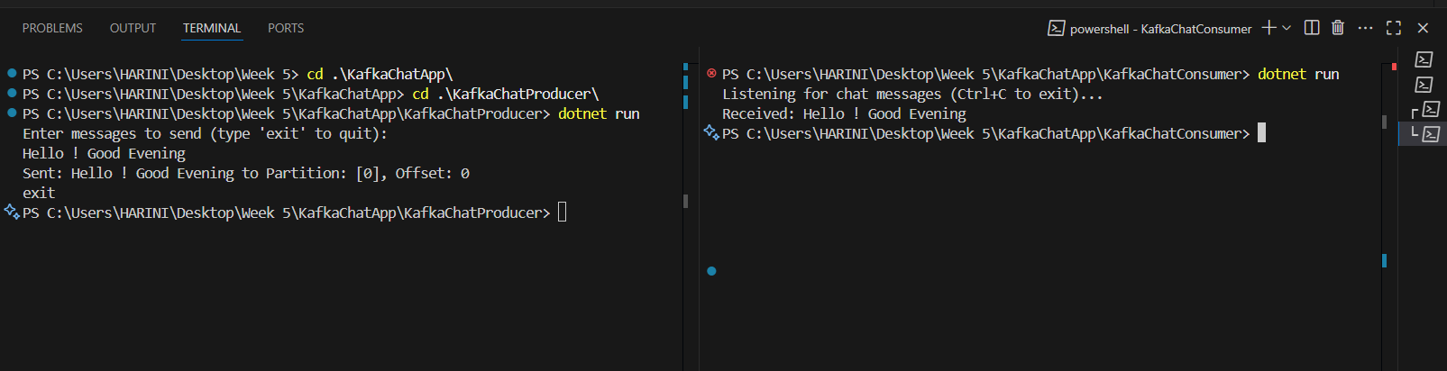

**2. Create a Chat Application using C# Windows Application using Kafka and consume the message in different client applications.**

**CODE:**

**Program.cs**

using System;

using System.Windows.Forms;

namespace KafkaChatWinApp

{

    internal static class Program

    {

        [STAThread]

        static void Main()

        {

            Application.SetHighDpiMode(HighDpiMode.SystemAware);

            Application.EnableVisualStyles();

            Application.SetCompatibleTextRenderingDefault(false);

            Application.Run(new Form1());

        }

    }

}

**Form1.cs**

using System;

using System.Threading;

using System.Threading.Tasks;

using System.Windows.Forms;

using Confluent.Kafka;

namespace KafkaChatWinApp

{

    public partial class Form1 : Form

    {

        private const string bootstrapServers = "localhost:9092";

        private const string topic = "chat-messages";

        private IProducer<Null, string> producer;

        public Form1()

        {

            InitializeComponent();

            var config = new ProducerConfig { BootstrapServers = bootstrapServers };

            producer = new ProducerBuilder<Null, string>(config).Build();

        }

        private async void btnSend_Click(object sender, EventArgs e)

        {

            string name = txtName.Text.Trim();

            string message = txtMessage.Text.Trim();

            if (string.IsNullOrWhiteSpace(name) || string.IsNullOrWhiteSpace(message))

            {

                MessageBox.Show("Name and message are required.");

                return;

            }

            string fullMessage = $"{name}: {message}";

            await producer.ProduceAsync(topic, new Message<Null, string> { Value = fullMessage });

            lstChat.Items.Add("[Sent] " + fullMessage);

            txtMessage.Clear();

        }

        private void btnReceive_Click(object sender, EventArgs e)

        {

            Task.Run(() =>

            {

                var config = new ConsumerConfig

                {

                    BootstrapServers = bootstrapServers,

                    GroupId = Guid.NewGuid().ToString(),

                    AutoOffsetReset = AutoOffsetReset.Earliest

                };

                using var consumer = new ConsumerBuilder<Ignore, string>(config).Build();

                consumer.Subscribe(topic);

                try

                {

                    while (true)

                    {

                        var cr = consumer.Consume(CancellationToken.None);

                        Invoke(new Action(() =>

                        {

                            lstChat.Items.Add("[Received] " + cr.Message.Value);

                        }));

                    }

                }

                catch (OperationCanceledException)

                {

                    consumer.Close();

                }

            });

        }

    }

}

**Form1.Designer.cs**

namespace KafkaChatWinApp

{

    partial class Form1

    {

        private System.ComponentModel.IContainer components = null;

        private System.Windows.Forms.TextBox txtName;

        private System.Windows.Forms.TextBox txtMessage;

        private System.Windows.Forms.Button btnSend;

        private System.Windows.Forms.Button btnReceive;

        private System.Windows.Forms.ListBox lstChat;

        protected override void Dispose(bool disposing)

        {

            if (disposing && (components != null))

            {

                components.Dispose();

            }

            base.Dispose(disposing);

        }

        #region Windows Form Designer generated code

        private void InitializeComponent()

        {

            this.txtName = new System.Windows.Forms.TextBox();

            this.txtMessage = new System.Windows.Forms.TextBox();

            this.btnSend = new System.Windows.Forms.Button();

            this.btnReceive = new System.Windows.Forms.Button();

            this.lstChat = new System.Windows.Forms.ListBox();

            this.SuspendLayout();

            this.txtName.Location = new System.Drawing.Point(12, 12);

            this.txtName.Name = "txtName";

            this.txtName.PlaceholderText = "Enter your name";

            this.txtName.Size = new System.Drawing.Size(300, 23);

            this.txtMessage.Location = new System.Drawing.Point(12, 41);

            this.txtMessage.Name = "txtMessage";

            this.txtMessage.Size = new System.Drawing.Size(300, 23);

            this.btnSend.Location = new System.Drawing.Point(320, 41);

            this.btnSend.Name = "btnSend";

            this.btnSend.Size = new System.Drawing.Size(75, 23);

            this.btnSend.Text = "Send";

            this.btnSend.UseVisualStyleBackColor = true;

            this.btnSend.Click += new System.EventHandler(this.btnSend_Click);

            this.btnReceive.Location = new System.Drawing.Point(320, 12);

            this.btnReceive.Name = "btnReceive";

            this.btnReceive.Size = new System.Drawing.Size(120, 23);

            this.btnReceive.Text = "Start Receiving";

            this.btnReceive.UseVisualStyleBackColor = true;

            this.btnReceive.Click += new System.EventHandler(this.btnReceive_Click);

            this.lstChat.FormattingEnabled = true;

            this.lstChat.ItemHeight = 15;

            this.lstChat.Location = new System.Drawing.Point(12, 70);

            this.lstChat.Name = "lstChat";

            this.lstChat.Size = new System.Drawing.Size(428, 214);

            this.AutoScaleDimensions = new System.Drawing.SizeF(7F, 15F);

            this.AutoScaleMode = System.Windows.Forms.AutoScaleMode.Font;

            this.ClientSize = new System.Drawing.Size(454, 300);

            this.Controls.Add(this.txtName);

            this.Controls.Add(this.txtMessage);

            this.Controls.Add(this.btnSend);

            this.Controls.Add(this.btnReceive);

            this.Controls.Add(this.lstChat);

            this.Name = "Form1";

            this.Text = "Kafka Chat App";

            this.ResumeLayout(false);

            this.PerformLayout();

        }

        #endregion

    }

}

**OUTPUT:**

